

Polling District and Polling Place Review 2026

Parklands and North Gosforth Ward – U02 and U03

Parliamentary Constituency: North

(Proposed) Polling District Changes: U02, U03

This document provides details of the review, along with the initial recommendations and comments of the (Acting) Returning Officer (ARO). Also, the election rules require the ARO to decide how many polling stations are required for each polling district and the ARO must allocate electors to the polling stations in such manner as they think most convenient.

This review is undertaken pursuant to Schedule A1 of the Representation of the People Act 1983. The review is an interim review limited to those polling districts affected by the ongoing Community Governance Review and is being conducted in accordance with the statutory requirements applicable to polling district and polling place reviews.

These recommendations will be open to all residents, stakeholders, and any interested parties. We shall be seeking representations from local disability groups on the accessibility and suitability of polling places. Any comments should be addressed in the first instance to pollingplaces@newcastle.gov.uk where they will be collated on behalf of the (Acting) Returning Officer.

We considered the following factors:

- Identifying new polling places: We will look for new polling places in areas where the existing provision is unsuitable or unavailable.

- Feedback: We will consider feedback received following recent elections, consultation from members of the public, elected members, and other stakeholders.

- Accessibility: We will try to ensure that every polling place is accessible to electors with disabilities.

- Facilities: We will make sure that all electors have such reasonable facilities for voting as are practicable in the circumstances.

- Elector numbers: We will try to comply with the Electoral Commission guidance on the maximum number of electors that should be allocated to a polling station which should not exceed 2,250.

- Future housing developments: We will consider the impact of proposed housing developments on polling station electorates.

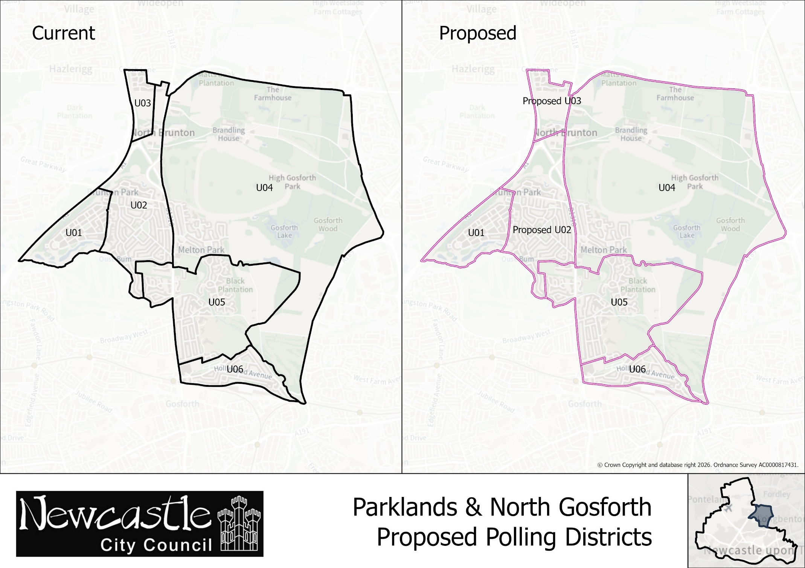
Parklands and North Gosforth Ward
Polling District U02
Current Polling District | Current Polling Place
U02 | St Aidan’s Community Centre, Princes Road, Brunton Park, NE3 5TT
Proposed Polling District | Predicted Polling Station  Electorate | Proposed Polling Place
U02 | 1,478 | St Aidan’s Community Centre, Princes Road, Brunton Park, NE3 5TT
Considerations and Proposals
Amend the polling district boundary so that it terminates at Rotary Way. Properties currently within the northern part of U02 polling district will transfer to U03 to reflect the recommended parish boundary changes arising from the Community Governance Review.

No change to the polling place.

St Aidan’s Community Centre is suggested as a double polling station to serve electors in U01 and U02 districts.

Current Polling District | Current Polling Place
U03 | Hazlerigg Community Centre, Hazlerigg, NE13 7AS
Proposed Polling District | Predicted Polling Station  Electorate | Proposed Polling Place
U03 | 240 | Hazlerigg Community Centre, Hazlerigg, NE13 7AS
Considerations and Proposals
Amend the U03 polling district boundary to align with the recommended Community Governance Review boundary changes, terminating at Rotary Way. This would incorporate the North Gosforth Park development within a single polling district and reflect the proposed expansion of the parish boundary.

No change to the polling place

This change to polling district boundaries would mean that electors at the northern part of the current U02 district would go to Hazlerigg Community Centre. Whilst this is in a different ward, it is situated closer to residents than the existing polling place at St Aidan’s Community Centre. It would also help balance electorate figures better and more evenly distribute electors across polling stations.

Hazlerigg Community Centre is suggested as a double polling station to serve electors in both U03 and E02 polling districts.

Parklands and North Gosforth Ward
Polling District U03

